**Tejas Bhandare Assignment – 01**

**Question 1**

function PrintMaxNumber(Num1 : number, Num2 : number, Num3 : number) : number

{

    if(Num1 > Num2 && Num1 >Num3)

    {

        return Num1;

    }

    else if(Num2 > Num1 && Num2 >Num3)

    {

        return Num2;

    }

    else

    {

        return Num3;

    }

}

var No1 : number = 23;

var No2 : number = 89;

var No3 : number = 6;

var MaxNum : number = 0;

MaxNum = PrintMaxNumber(No1, No2, No3);

console.log("Maximum number is "+MaxNum)

**Output :**

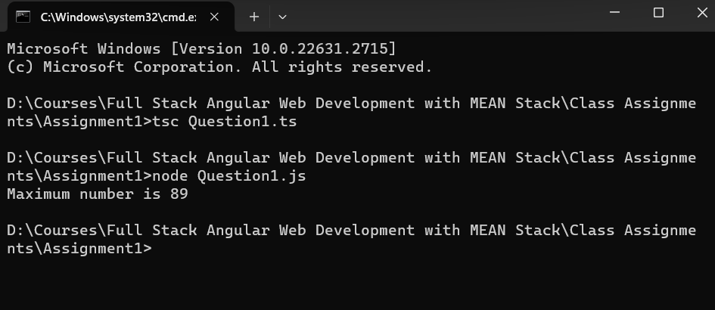

**Question 2**

function CalculateArea (Radius : number) : number

{

    var PI : number = 3.14;

    var Area = PI*(Radius*Radius);

    return Area;

}

var CircleRadius : number = 5;

var CircleArea : number = CalculateArea(CircleRadius);

console.log("Area of circle is "+CircleArea);

**Output :**

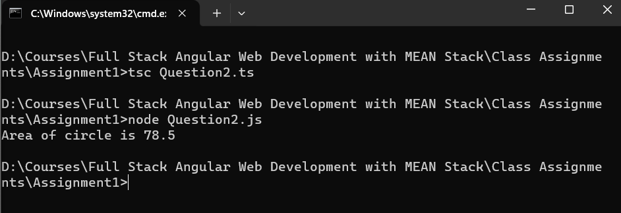

**Question 3**

function DisplayFactors (Num1 : number) : number[]

{

    var CurNum : number = 1;

    var Factors : number [] = [];

    while(CurNum < Num1)

    {

        if(Num1 % CurNum == 0)

        {

            Factors.push(CurNum);

        }

        CurNum++;

    }

    return Factors;

}

var No1 : number = 20;

console.log(DisplayFactors(No1));

**Output :**

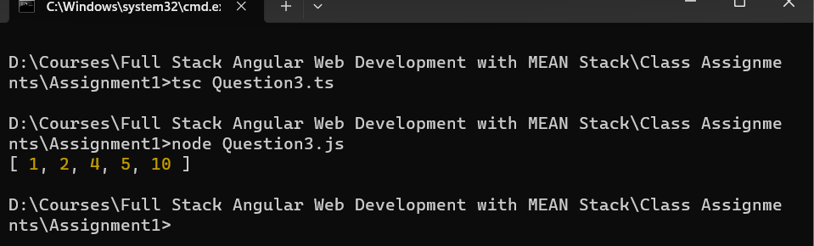

**Question 4**

function CHkPrime(Num1 : number) : boolean

{

    if(Num1 == 2 || Num1 == 3 || Num1 == 5 || Num1 == 7)

    {

        return true;

    }

    else if (Num1 % 2 == 0 || Num1 % 3 == 0 || Num1 % 5 == 0 || Num1 % 7 == 0)

    {

        return false;

    }

    else

    {

        return true;

    }

}

var No1 : number = 11;

var Result : boolean = CHkPrime(No1);

if(Result == true)

{

    console.log("Number "+No1+" is a Prime Number");

}

else

{

    console.log("Number "+No1+" not a Prime Number");

}

**Output :**

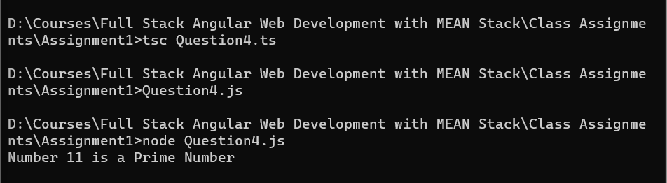

**Question 5**

function printFibonacci ( num : number) : number[]

{

    var fibonacciSeries : number[] = [];

    var curNum : number = 0;

    var preNum : number = 1;

    var temp : number = 0

    while (curNum <= num) {

        fibonacciSeries.push(curNum);

        temp = curNum + preNum;

        preNum = curNum;

        curNum = temp;

    }

    return fibonacciSeries

}

var No1 : number = 21;

console.log(printFibonacci(No1));

**Output :**

